Colin’s Car Detailing Expansion
Presented to Colin Ford

Executive Summary
Problem Faced:

Passage was anxious to develop his young organization, however he was additionally set to start considering trade at the University of British Columbia in Vancouver, British Columbia, in September. Thusly, his main concern was guaranteeing that he had enough assets to pay educational cost and cover his other individual costs for the principal year.
Criteria Used:
We made a weighting framework that broke down five key components we accepted to be generally appropriate to CCD's present circumstance. Extended expansion in income is significant in guaranteeing that the decision made enables CCD to achieve the point of bringing in enough cash to guarantee that Colin can pay for tutoring. Surveying the underlying expenses of every choice was significant also, as the more costly alternatives would need to acquire more business to make them worth the danger. Every potential decision accompanied likely new working expenses too, choices that additional higher working expenses would likewise need to get more cash to counterbalance these expenses. Breaking down the time it would take to execute each new methodology is significant too, as time taken actualizing another procedure probably defers activities that can acquire income. The last class we investigated was responsibility. As this is Colin's first undertaking the alternative to pull back or alter course is essential to consider. A portion of the alternatives are more hard to progress from and we considered in our examination.
Solution Generated:
CCD could band together with a public nine-opening golf that was found around a five-minute drive from Ford's home. The green charges at the course were moderate comparative with different courses in the territory, and the course basically pulled in supporters from inside the network. Portage thought promoting through the green could be a powerful technique to draw in extra clients. To lure clients to utilize the administration, Ford anticipated leaving flyers and business cards in the professional shop and a sign publicizing CCD outside the genius shop's front entryway. The sign would cost around $150.Clients could book arrangements through the fairway's genius shop to have their vehicle nifty gritty while they played a series of golf. At the point when the clients appeared for their tee time, Ford would get their vehicle, drive back to CCD's present area (Ford's home) for itemizing and afterward return the vehicle to the fairway before the finish of the client's round (the normal round at the course took two hours and 20 minutes to finish).

Introduction
We are presented with the case of Colin’s Car Detailing service; Colin is deciding between many different options for his business, as he is going to be enrolled in his first year of classes for school at the University of British Columbia. He faces the dilemma of ensuring that he has enough funds to cover his tuition and personal expenses for the first year. Located in West Vancouver, Colin is trying to decide whether to purchase a rotary buffer and apply cut polishing into his service, if he should purchase a truck and make an entrance into the mobile market, obtain a partnership with a public nine-hole golf course and provide detailing service while customers are golfing, to franchise his business into North Vancouver, or to sell his business and liquidate his equipment. Canada’s recent economy had a negative impact on the business, but now the economic growth is expanding, and is looking to maintain that growth into the coming future. The demand for detailing service was likely to increase because of the economic growth increase. Environmental awareness and responsibility would also come to affect the demand for the business, as professional detailers would use a third of the amount of water versus washing your vehicle at home. As well as municipalities becoming stricter on what is allowed into storm drains.

Colin’s detailing service was founded 4 years ago, while Colin was just 14 years old and having no work experience. When first starting out, Colin attempted to have extremely low prices for services, 85% less than other local car detailing services. After investigating why people are not taking the offers of his low price, they determined that customers were skeptical of the low prices, after Colin raises the price to a more realistic amount, people start taking his higher end services instead of just a wash and vacuum. Colin’s competitors consisted of Rod’s Exotic Auto Spa, this service held a valuable reputation that allowed it to charge a range from $350 to $450. Blitz Auto Spa would be the biggest threat to Colin’s business, as they were the closest to price, offering full services from $295 to #395, while also offering 25% off discounts to customers, which would then make the price range from $221.25 to $296.25. There is also Park Royal Hand wash, that charged the cheapest at $29.95, but lacked the valuable services, such as interior shampooing or exterior polishing and waxing, this option is best suited for people that are looking for a quick and convenient cleaning without going too in depth.

Weighting and Recommendation
To select the best option we created a weighting system that analyzed five key elements we believed to be most applicable to CCD’s current situation. Projected increase in revenue is important in assuring that the choice made helps CCD accomplish the aim of making enough money to ensure that Colin can pay for schooling. Assessing the initial costs of each decision was important as well, as the more expensive options would need to bring in more business to make them worth the risk. Each potential choice came with potential new operating costs as well, options that added higher operating costs would also need to bring in more money to offset these costs. Analyzing the time it would take to implement each new strategy is important as well, as time taken implementing a new strategy likely delays operations that can bring in revenue. The final category we looked into was commitment. As this is Colin’s first business venture the option to pull back or change direction is important to consider. Some of the options are more difficult to transition from and we took this into account in our analysis.
Upon finding the top two options based on our selected criteria, we performed SWOT analysis on each of them. This was done to more thoroughly evaluate the strengths and weaknesses of each option. After completing this analysis we came to the conclusion that the best option going forward for CCD is the golf course partnership, with franchising being another strong option.

Golf Course Partnership
The option of a golf course partnership is our primary recommendation because of it’s high chance of bringing in new business, along with its low costs and level of commitment. The main reason the golf course option is so strong is because of the clientele that frequented golf courses. According to the Vancouver Board of Parks and Recreation, there are 55 000 plus rounds of golf played annually at individual golf courses in the area. 81% of the people golfing in the Vancouver area are between the ages of 19-64, which lines up with the most common age range of car owners. The busiest season of golf also coincides with the busy season of Colin’s business, a further reason this choice line’s up well with the business done by CCD.
The main issues tied to this decision are the new difficulties in scheduling appointments, as well as the 10% fee paid to the golf course on each appointment booked through the golf course. The issue of scheduling can be easily dealt with by using a shared online calendar system. There are many free options available for this purpose, such as Google Docs. Not only do these services allow for two or more people to add booked appointments to the calendar, it also allows the user to see who booked each appointment, allowing Colin to track which appointments are booked by the golf course and ensure the 10% fee is paid on those bookings.
To accommodate for the 10% fee paid to the golf course, we recommend that Colin raise his prices to the range of $200-240 for his services. Doing this would ensure that profits increase despite the new fees paid to the golf course. These prices are still highly competitive in relation to CCD’s competitors, as these prices are still at least $55 dollars cheaper than the closest direct competition.
Finally, it is clear that Colin is proud of and prioritizes his current good relationship with his current clientele. To ensure that the golf course bookings do not completely overtake his schedule, we recommend that he only allow the golf course to make bookings for weekday afternoons and weekends. This allows clients not going through the golf course more options for booking as they will still be able to book empty slots that are available to the new clients as well as the times allotted only to them. CCD’s current clients may be dissatisfied by the price increase, however we believe that if Colin emphasises the value of his prices in comparison to the competition and promises the same high quality performance his loyal customers will be understanding. Finally we recommend that Colin continue the practice of hiring extra help in the summer to assist with the new workload and enable him to book more appointments. The wage of these hirings will still be covered by the price increase, resulting in higher profits overall.
Franchising

Conclusion

Appendix

 | Projected Revenue Increase | Upfront Costs | Operating Costs | Implementation Time | Commitment | Total
Cut Polishing Services | 6 | 3 | 6 | 5 | 4 | 24
Go Mobile | 7 | 1 | 2 | 3 | 2 | 15
Golf Course Partnership | 6 | 8 | 8 | 9 | 8 | 39
Franchising | 8 | 7 | 7 | 2 | 6 | 30

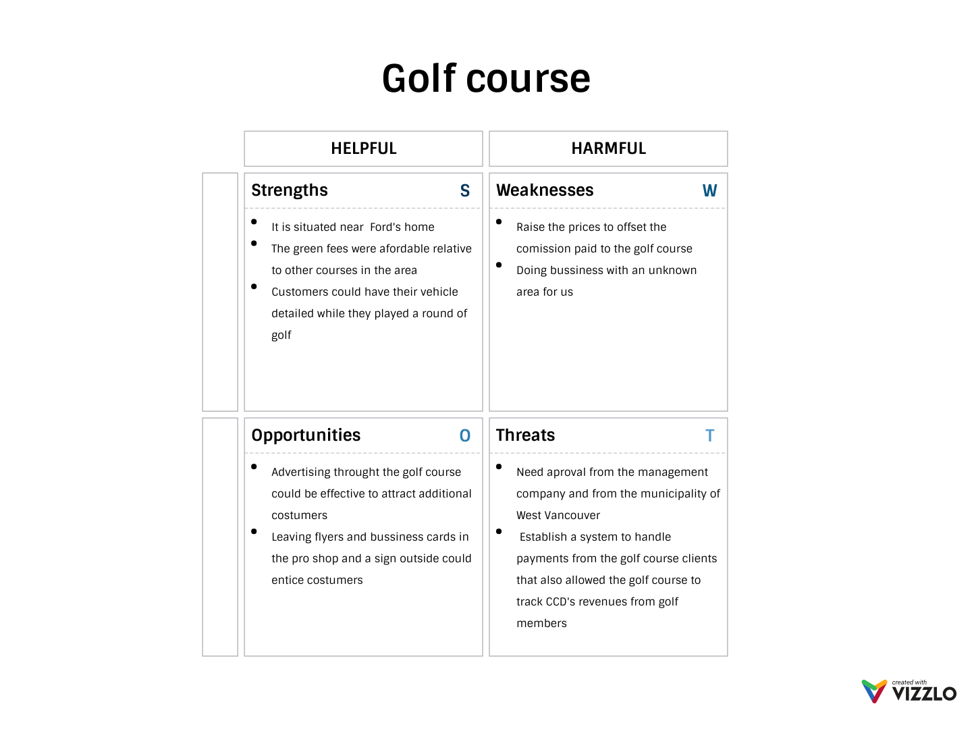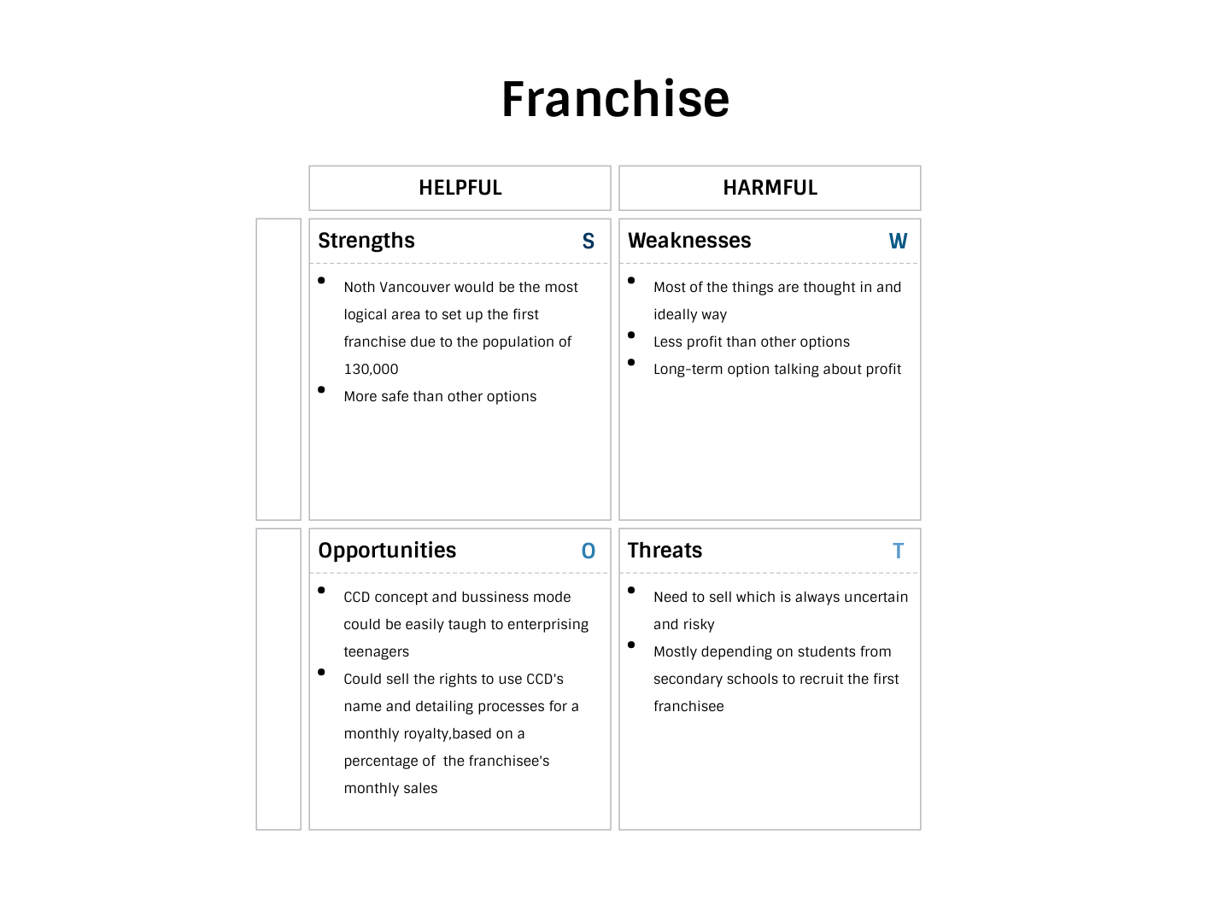

References

https://parkboardmeetings.vancouver.ca/2012/121105/Golf%20Course%20Metrics%20Update.pdf

